**IMVFX Assignment1 Report**

* Finding KNN for the given image

In this Part, first define feature vector of each pixel and store in feature_vec variable. After feature vector is defined, computing K nearest neighbors according to each pixel in the feature space

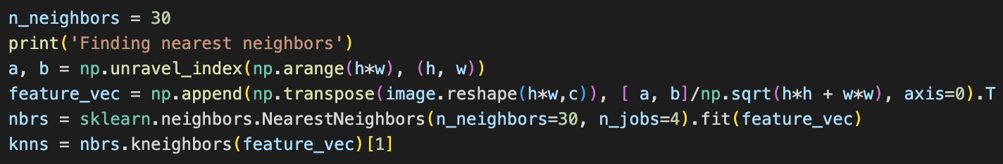

* Compute the Affinity Matrix A

Using feature vector to compute kernel function k(i, j), and store in sparse matrix A

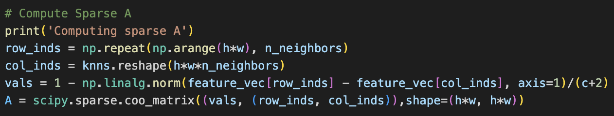

* Solve the linear system

First organize each variable to form the objective function, solve the linear system according to below equation and store in alpha.



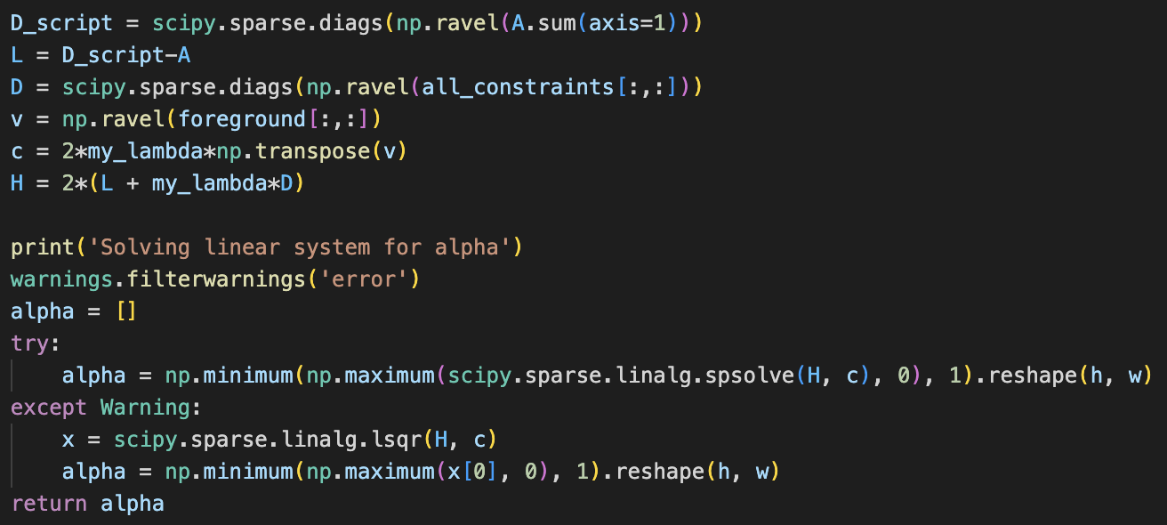

* Composite images

First store foreground and background, and construct the composite image by adding foreground and background according to the formula.

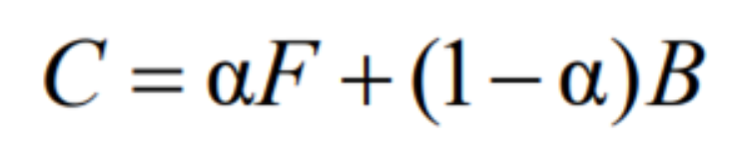

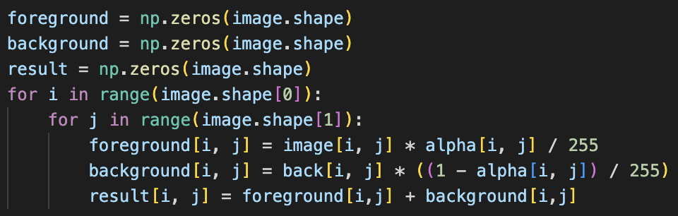

* Experiment

In experiment, I try different number of K to test the quality of alpha matte, below is the result.

|  |  |
| --- | --- |
| KNN-neighbors num | Alpha matte |
| 10 |  |
| 30 |  |
| 100 |  |

As you can see, the bigger number of K, the detailed of the alpha matte. However, the difference of time consumption between different number of K is enormous. When K=10, it takes about 10 sec to generate the image, while K=100, it almost take 10 min to generate the image.

|  |  |  |
| --- | --- | --- |
| 10 | 30 | 100 |
|  |  |  |

* Result

Each image composite with background in neighbor num=10

|  |  |
| --- | --- |
|  |  |

|  |
| --- |
|  |

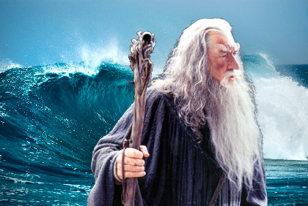

K=10

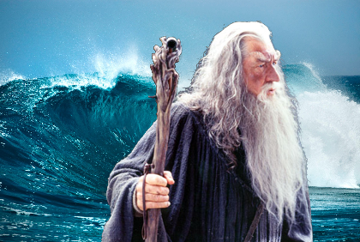

K=30

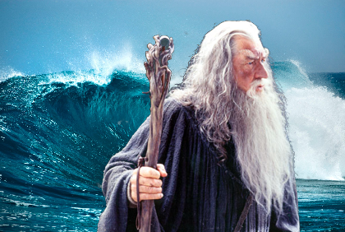

K=100